## competencies table

## Fields

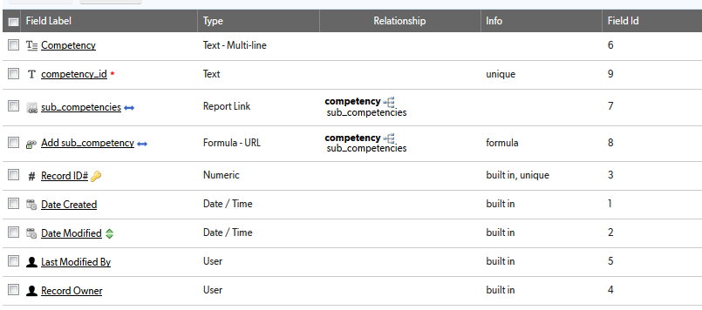

## Relationships

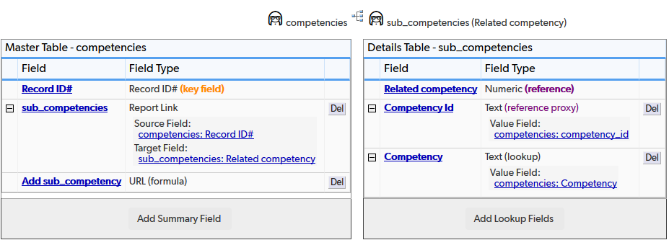

## Field settings

Note: Built-in fields use the default settings

Competency 2

competency_id 3

sub_competencies 4

Add sub_competency 5

# Competency

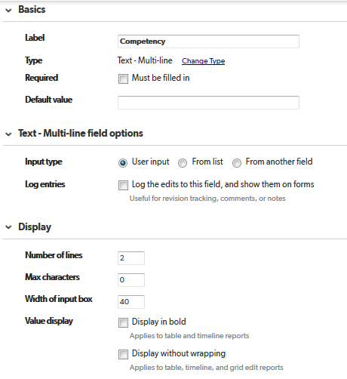

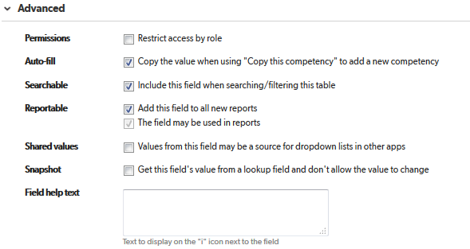

# competency_id

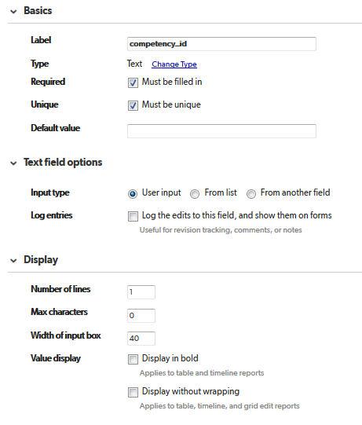

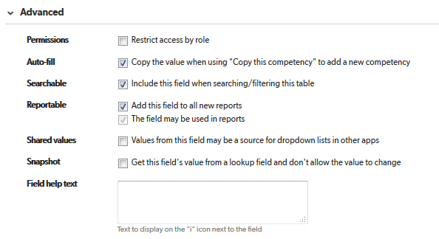

# sub_competencies

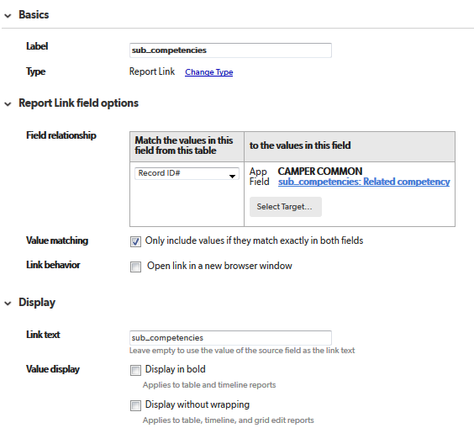

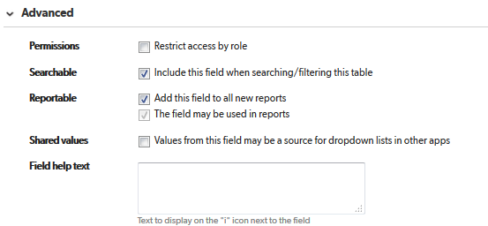

# Add sub_competency

